Stefan Grulović

Alexandros Astaras

Computer Science 330: Introduction to Mobile Robotics

SPRING 2018

Final Project Word Report

# Project Brief Description

The project for CS330 Mobile Robotics was to make the robot preform two tasks around a circuit. The first task was to make the robot go around the track and check the egg possible positions of A, B and C and when it finds the egg take it to the end. The second task was to make the robot go around the circuit and check the colours of the three cups positioned in the A, B and C yellow sections and when it finishes identifying the colours go to the end.

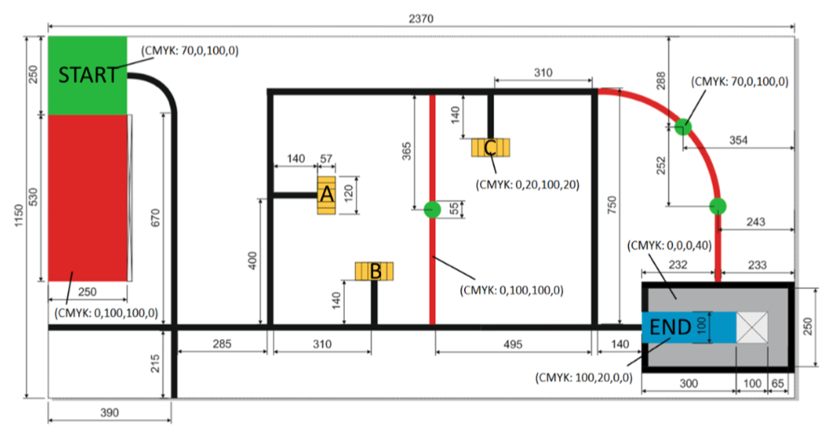

*Example of the robot circuit*

# Hardware part

The robots used for the project were Lego Mindstorms EV3 robot kit, which has a hardware and software platform for programming robots. The robot is based of Lego building blocks making assembly and construction of the robot fairly easy.

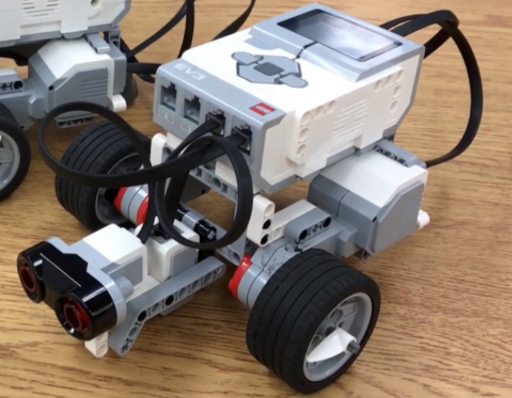

*Example of the Lego Mindstorms EV3 in the form used for the project*

The robot kits are accompanied by building instructions from Lego which are quite detailed and easy to follow. Overall, all this makes the basic usage of the robot easy to follow and understand. Making the robot do basic movements such as go straight, turn left etc. fairly easy which is great for beginning as you are not discouraged from the start. However, fairly soon you realize that the sensors which the robots have are not as precise as one might imagine. The ultrasonic sensors and light sensor are the main thing which gave the most troubles while doing this project. Ultrasonic sensors sometimes see the object in front and sometimes doesn’t which is right in front. Similar thing with colour sensor which sometimes registers a colour when scanning and sometimes doesn’t. Also, slight variations of environment could easily affect the robot and make it do something which was not intended or something which wasn’t present before. For example, one might shake the course circuit and slow down the robot making any tasks which uses a timer to fail as the robot now took more or less time to come to a specific point. The ambient light of the room could change which would then affect the readings of the colour sensor when following a line or when checking a colour of an object. The batteries may run out of energy making the robot preform slower affecting its overall performance while one might think there is something wrong with the code. These are the main problems which produced the most error and stress as the goal is to make the robot preforms the task perfect every time the program is ran. To conclude, robot sensors are quite sensitive and do represent one of the main obstacles when one might want to program a robot.

# Software Part

Regarding he software part of the project there weren’t many issues. It didn’t provide as much as troubles as the hardware, mainly due to the syntax of RobotC which was fairly easy to catch upon.



*Programming language used*

After building the basic library of moving the robot most of the programming was done. The main time-consuming part of programming was changing the numbers up and down until the middle value which satisfies most of the possible scenarios is found. Clearly robots tend to behave unexpected mainly due to the sensitivity and lack of precision of the sensors. Making the main challenges and directions of programming a robot to hardcode the robot or to make the code so flexible in order to take into account everything. Finding the middle value which satisfies all the possible scenarios is quite repetitive and doesn’t seem as the right thing to do. Due to time pressure though it was more preferable in the obstacles presented in the realization of the project. The other choice would be to create a complex code which would normally take into account possible changes in the environment and act accordingly. This would make the robot feel more as it is preforming a task on its own as it is taking into account and calculating all the values of the environment around, rather than making it hardwired.

# For the future

For the future main improvement would be the programming part as the parts which can be used are made by Lego and there is not much choice there. Improving the library and making it code more flexible regarding taking into account all the possible scenarios. Focusing on scenarios and environment around which can occur normally and not in hardwiring. The tasks which we are asked to perform would greatly improve the reliability and performance of the robot. Regarding the assembly part of the robot there is no need to improve much as the build of the robot is sturdy. Overall, the project was interesting and quite eye opening regarding how the sensors can be imprecise and present a great obstacle for the programmer of the robot.